**S&D Team Hackathon 4.0**

**Problem Statement –**

**GenAI** is the latest trend in the industry and every company is trying ways to adopt it. We at ABI (S&D team) taking a challenge to build a new capability using GenAI. The last mile delivery of CatMan project is ‘Planogram’ which gets activated across physical stores. But currently we don’t have a feedback loop which can validate the adherence. Your team needs to find a way to identify SKUs present in Real Planogram photos and save that information in a database. Using OpenCV or any package, develop an algorithm/model to produce real time SKU classification/identification for any given photo.

**Key Tasks -**

1. Building an Image Segmentation / **Object Detection** **model** optimized for SKU detection in shelf images.

**Note:** Usage of Machine Learning techniques is not compulsory in this case. But we have provided ample training (and test) data in case you wish to implement ML in this step.

1. Using the above **model**, developing an **image** matching / object **recognition** algorithm to identify the quantity of SKUs present in each of the evaluation images.

**Data:**  
Training Data:

* 1. Large dataset of SKU shelf images with labels

SKU Catalog:

* 1. Catalog of images containing individual photo of each SKU. (sku_id.jpg) (all relevant SKU images)

Test Data:

* 1. Set of images to be used for final validation of “SKU Identification” **(2 images**)

**Link to understand format of Training Data:**

[**https://www.kaggle.com/code/thedatasith/visualize-sku110k**](https://www.kaggle.com/code/thedatasith/visualize-sku110k)*This Code can be used to understand how the labels provided with the training data is formatted. Use this to visualize the labels and images with segments***.**

**Expected Output:**

Dataset containing the SKUs present in each photo with the quantity as well. Ex:

|  |  |  |
| --- | --- | --- |
| **img_name** | **sku_id** | **quantity** |
| img_1 | id1 | 5 |
| img_1 | id2 | 10 |
| img_1 | id5 | 15 |
| img_2 | id11 | 1 |

**Example Data:**  
 Here is a sample Shelf Photo

Here is the same photo with segmentation

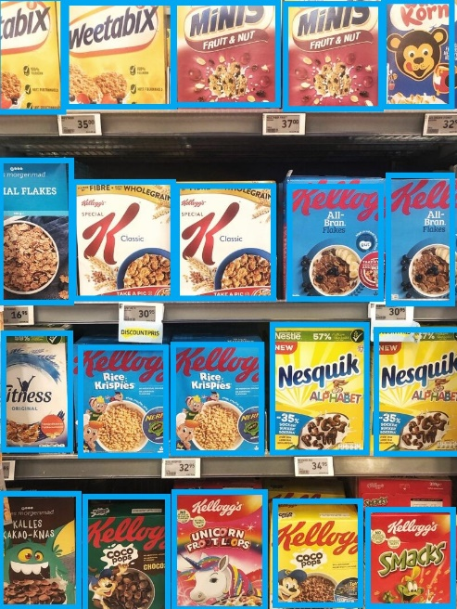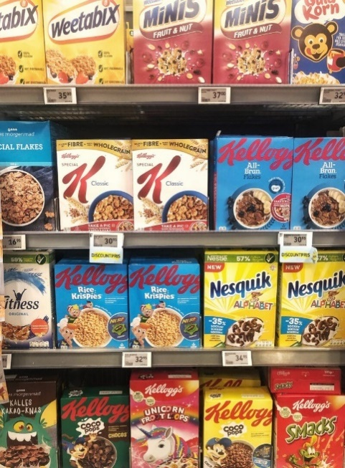

img_1_segmented

img_1

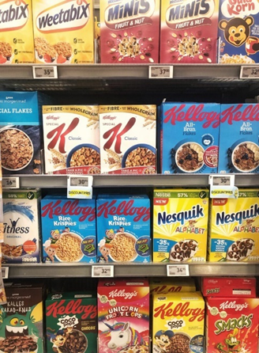Using the SKU image catalog provided to you:

sku_4

sku_3

sku_1

sku_2

The expectation is to identify how many of each SKU from the catalog are present in each image.

Ideal **output** for above given example would look like this:

|  |  |  |
| --- | --- | --- |
| **img_name** | **sku_id** | **quantity** |
| img_1 | sku_1 | 2 |
| img_1 | sku_2 | 2 |
| img_1 | sku_3 | 2 |
| img_1 | sku_4 | 2 |

**Evaluation**: Evaluation will be measured on the output from the final evaluation data. We will use the Jaccard Index (IoU) to calculate the accuracy of the results. The team also needs to create a Presentation of not more than 8 slides (10 + 2 mins) to showcase their work.

**Useful Resources:**

1. [SKU Training Dataset Source](https://www.kaggle.com/datasets/thedatasith/sku110k-annotations) – The source of the Training Data
2. [Feature Detection and Matching + Image Classifier Project | OPENCV PYTHON](https://youtu.be/nnH55-zD38I)
3. [OpenCV Python Tutorials](https://youtube.com/playlist?list=PLzMcBGfZo4-lUA8uGjeXhBUUzPYc6vZRn)
4. <https://segment-anything.com/>
5. <https://www.geeksforgeeks.org/detect-an-object-with-opencv-python/>
6. <https://app.pluralsight.com/library/courses/mining-data-images/table-of-contents>
7. <https://www.linkedin.com/learning/computer-vision-deep-dive-in-python/computer-vision-under-the-hood?autoplay=true&u=26137906>